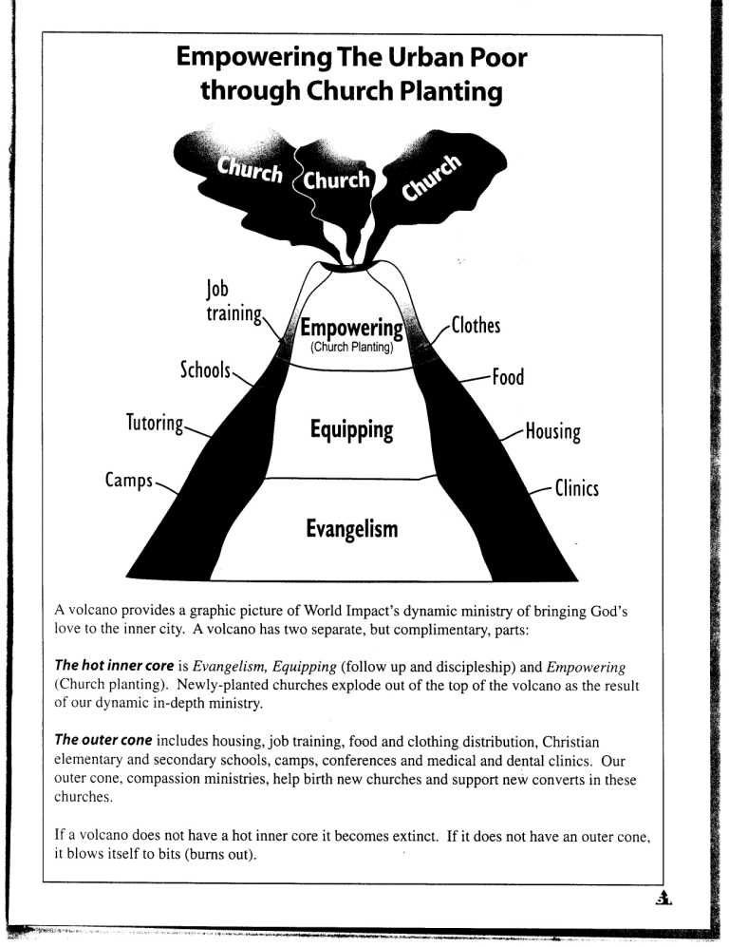
Diagram from World Impact

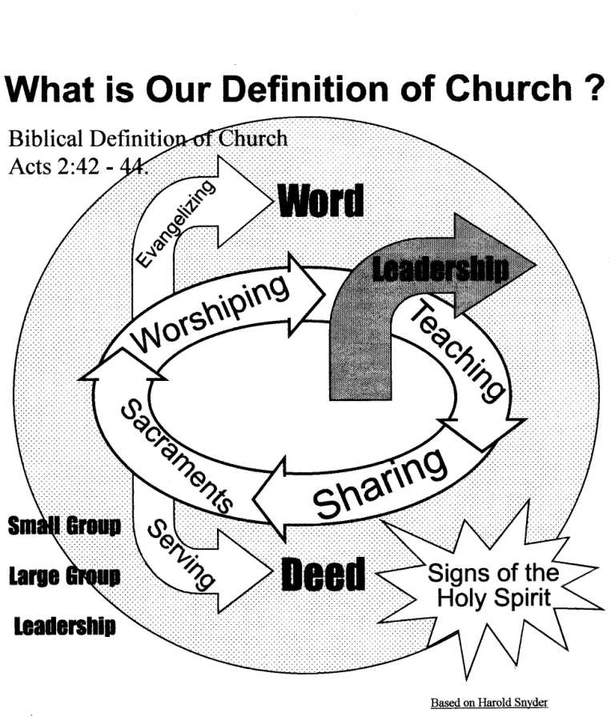
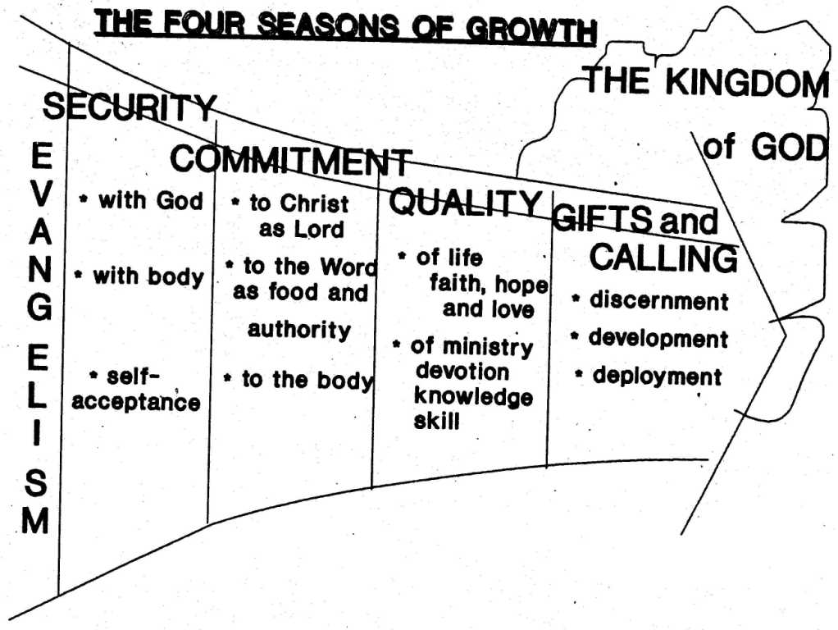
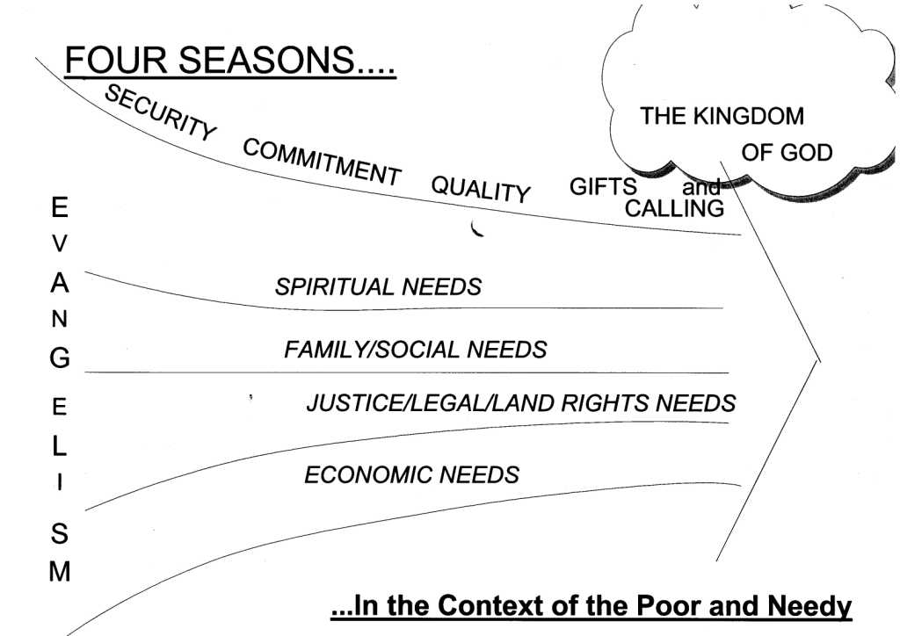

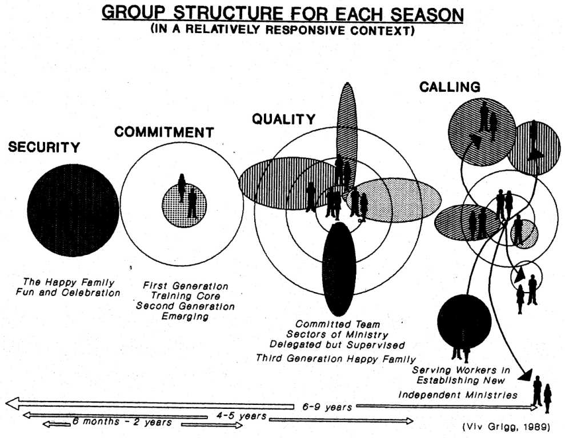

Developing a Work Plan
1. Discuss with your group, what stage you are at. Put the numbers in the At Present box or a date you want to start
2. Decide on the next steps and what you want to ask God. Place in the target box
Be realistic. It takes time to build well.
3. Make a copy on the next page, tear out and give to the training coordinator, so we can evaluate where the group as a whole are up to.

 | Present number of people | What you want to do next | Target Date
Contacts (no of people you church met each week in the community)
Cells (number of small groups doing Bible study)
Converts (number over last year)
Celebration (number at big events)
Congregation(Weekly attendance)
Community Development (number of people your church serves in the community each week)

Work Pattern for Evangelism
Write in the box below 4 or more new things you want to do for evangelism
Prioritise these, 1,2,3,4, and then put a target date
Make a copy on the next page and give to the training coordinator

Style of Evangelism | What you plan to do | Target Date | Priority
Presence Evangelism
Prayer Evangelism (Blessing homes)
Power Evangelism (places or people in need of deliverance or healing)
Proclamation Evangelism
a. Public Preaching
b. Literature distribution
c. Radio, Jesus Film
Other

Name __________________
Copy the results from the previous page and pass in to the training coordinator

 | Present number of people | What do you want to do next? | Target Date
Contacts (no of people you church met each week in the community)
Cells (number of small groups doing Bible study)
Converts (number over last year)
Celebration (number at big events)
Congregation(Weekly attendance)
Community Development (number of people your church serves in the community each week)

Work Pattern for Evangelism
Style of Evangelism | What you plan to do | Target Date | Priority
Presence Evangelism
Prayer Evangelism (Blessing homes)
Power Evangelism (places or people in need of deliverance or healing)
Proclamation Evangelism
a. Public Preaching
b. Literature distribution
c. Radio, Jesus Film
Other

- Four Seasons Work Flow – Teaching Plan

- Break into Groups – each focus on one season

- For your Seasons define the topics you will teach
  - Decide on which bible books, passages you will use or which bible study materials
  - Decide on which cultural value or story you will begin each study with
  - Decide on how you will intersperse these with social events (3 weeks? 4 weeks, 6 weeks, celebration events?)

Security Season
Topic | Passage | Story | Event
Commitment Season
Topic | Passage | Story | Event
Quality Season
Topic | Passage | Story | Event
Gifts & Calling Season
Topic | Passage | Story | Event

Share with the larger consultation.

Worksheet: Cash Flows in an Urban Poor Churchplant
Name: _________________________ Church you are discussing: ___________________
Location: Slum / Rural / Town (circle one)

Reflect with your group on the cash flow needs of a church-plant you have been involved in. Try to estimate what it cost, how long after first entering the community it took, and the difficulties faced because of lack of resources

 | Cost | Time after entering | Sources of income | Problems
Entrance
First converts
First 5 cells
First worship
Building started
Building usable
Building finished
Pastor ½ supported
Pastor fully supported
Care for aids victims, orphans
First community development project
Community worker
Community centre
Credit cooperative, loans fund etc

What would you do differently next time about funding a churchplant?

What is the balance between God providing for you, and you working hard to earn what you need? _____________________________________________________________________

Tear out and pass to the training coordinator.

Diaconal Growth : Dealing With Poverty
Read, Cry Chap 20, Bread For The Poor Or Bread And The Bread Of Life?

- Traditional Responses
    - Community Development – deals with socio-economic issues
    - Community Organization – deals with power issues of conflict

- A Pattern for Community Development
    - God’s intentions based on Luke 2:52 is that we minister wholeness to a broken world
- God’s intentions for an individual
- God’s intentions for a church
- God’s intentions for a community
    - Four areas of need

- 9 Steps in Community Organization
    - Entrance
      - 5 Roles
      - Earned / Ascribed Status
      - Covenant with other leaders / Legal Protection
    - Networking
      - To elected leaders
      - Identifying natural leaders
    - Definition (Gods Intentions)
      - Luke 2 : 52 Presentation
    - Planning Committee
    - Single Project
      - Manageable size
      - Reasonable probability of success
    - Reflection-Action Cycle
    - Leadership Emergence
    - Multiplier Effect
    - Community Transformation

- Ethics in Community Organization
    - Community leadership acts responsibly
      - Open covenants arrived at openly
      - Clear objectives, democratically arrived at and clearly formulated
    - Clear use of power for clear use of objectives
    - If not definition of what power is being used for
    - Checks and balances, and principle of consent by those being lead
    - Methods consistent with the ends
    - Integrity in leadership
    - Institutional integrity
      - The principle of plurality means the participants must participate for the good of the community and not their own advantage
- Three Movements To Impact Squatter Poverty
- How the Poor Escape Poverty
    - Mutual Aid Associations
      - The Rochdale Principles
      - e.g. Tatalon revolving loan fund
      - Problems with cooperatives
    - Functioning Roles as Middlemen
    - Migration as a Solution to Poverty
    - Education – the Way Out

Middle Class Solutions to Poverty
- Poor Peoples Banks
  - Grameen Bank Experiment
    - To obtain loans must be group of five
    - Whole group is made liable
    - Repaid on a weekly basis
    - Bank goes to the people
    - Helps the poor plan their savings
    - 40% of bank stock owned by poor who have been helped
- Businesses to Lift the Poor from Poverty
Bruce Kirchhoff, Prof. of entrepreneurship at New Jersey Institute of Technology quoted in the Christian Science Monitor Spiking Sterotypes About Small Firms May 7, 1993 tells us only 18% of small businesses fail during the first 8 years. 28% voluntarily terminate without loss to creditors, 28% survive with their original owners and 26% survive with a change of ownership. Larger starts ups with 4 or more employees, are twice as likely to survive for eight years.
  - Go with Industrialization
    - Not agriculture or handicrafts
    - But agricultural processing of food, clothing
    - Move into developing sectors such as electronics, welding, computers
    - All require training in basic bookkeeping skills.
            - Cooperatives – Means of Economic Uplift

Philosophical Issues in Development
- Personalized not programmed
- Development from the Center
- Priorities the poor Perceive
- Expected Percentage of Failure
- Community Involvement
- The Multiplier Effect
    - Patterns – Development Of A Diaconal Team
      - Example of a Diaconal Meeting
    - Roles of Missionaries, Elders, Diaconates

The Role Of The Rich Church In Fighting Poverty
(Read Cry Chap 21)
    - Transfer Of Capital And Expertise
    - Simplicity As A Biblical Lifestyle For The Rich
    - Confrontation With Injustice
Finale

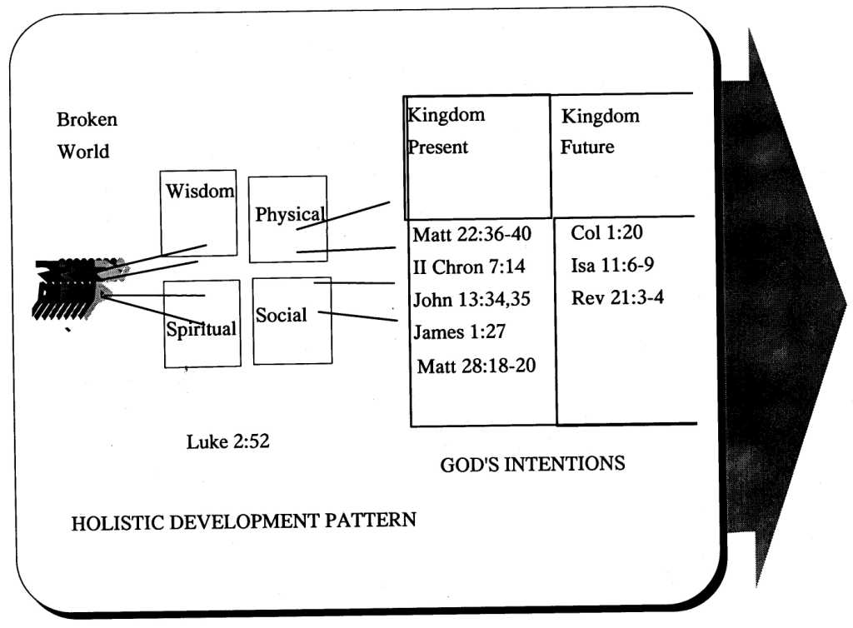

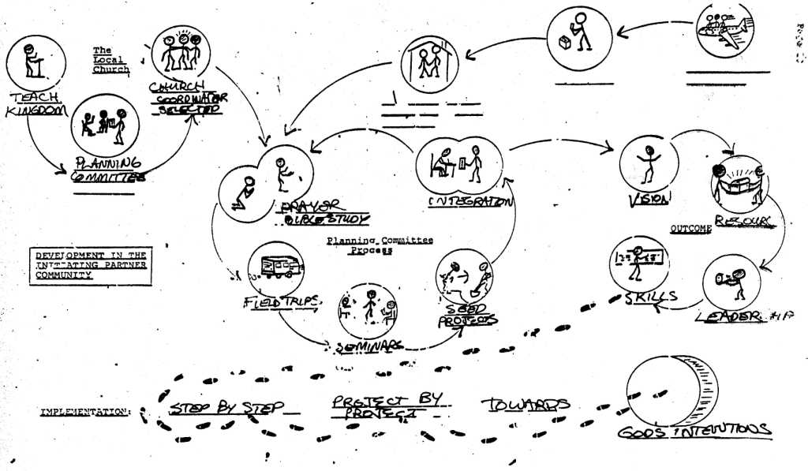

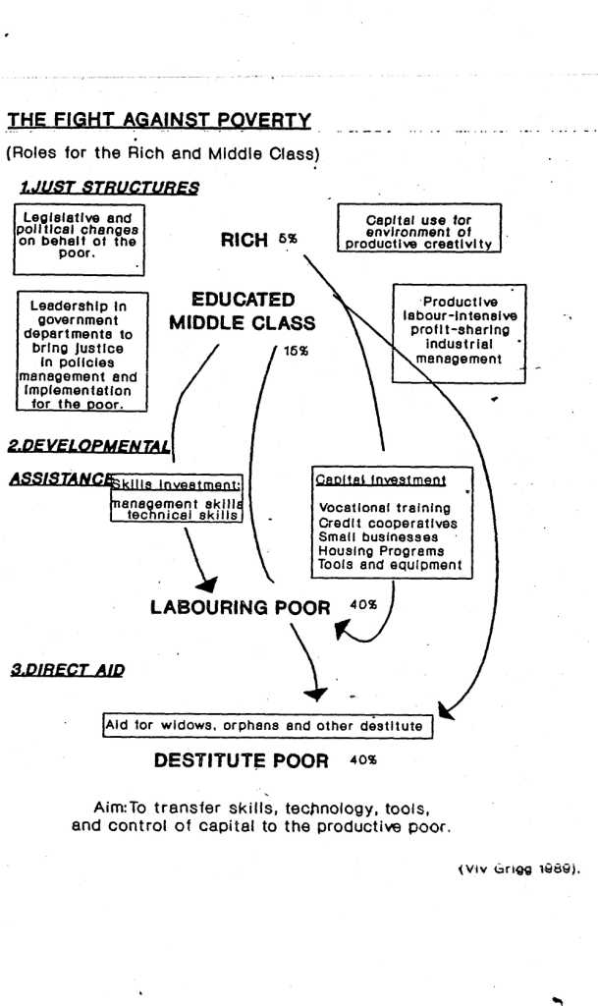

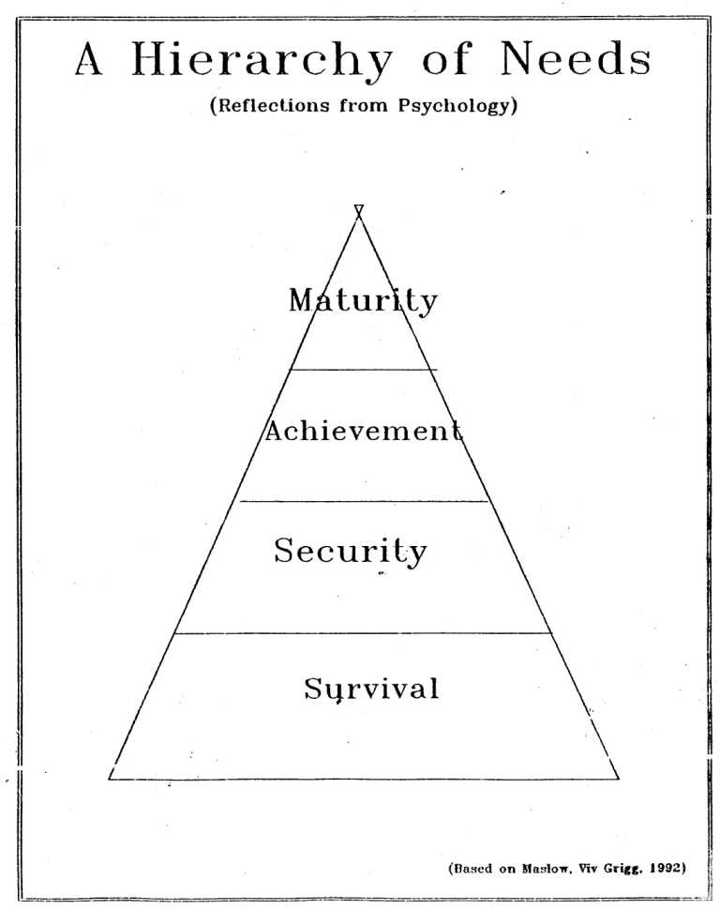
Setting the Economic Captives Free

Survey of Economic Production of Congregation and Community

God commanded us to manage the earth and the resources it produces. This also means to mange wealth. The following are the beginnings of exploration and discussion to help people move towards productivity.

From Debt to Savings

How do individuals manage their wealth in your community? Are there informal schemes where people help each other in groups? Banks? Cooperatives? In different countries there are different names - merry-go-rounds, tontines, paluwagans, cash rounds….?
__________________________________________________________________________
__________________________________________________________________________
__________________________________________________________________________
__________________________________________________________________________

How do your church members manage wealth? Is there any difference between your church members and those in the community with regard to debt and management and savings?
__________________________________________________________________________
__________________________________________________________________________
__________________________________________________________________________
__________________________________________________________________________

How do people temporarily convert the assets they have (land, jewelry etc) into cash when needed? Are there pawnbrokers that operate in the community?
__________________________________________________________________________
__________________________________________________________________________
__________________________________________________________________________

How do people obtain immediate access to sums of money now in exchange for future savings? These are usually known as loans that come through money lenders, cooperatives, banks, savings and credit associations. What rate of interest do they charge?
__________________________________________________________________________
__________________________________________________________________________
__________________________________________________________________________
__________________________________________________________________________

How do people in the community provide for known life-cycle expenses such as births, deaths, marriages etc.? Is the church different to the community in caring for these events?
__________________________________________________________________________
__________________________________________________________________________
__________________________________________________________________________
__________________________________________________________________________

Where do people obtain funds for emergencies?
__________________________________________________________________________
__________________________________________________________________________
________________________________________________________________________

Production

How do people in the community find access to money to finance for small economic activities, small businesses? How do people in the church access such money?
__________________________________________________________________________
__________________________________________________________________________
__________________________________________________________________________

List the four best ways people in your community actually escape poverty?
__________________________________________________________________________
__________________________________________________________________________
__________________________________________________________________________
__________________________________________________________________________

8a. What is your church doing to assist them in these four ways?
__________________________________________________________________________
__________________________________________________________________________

Churches help people in the next steps to be successful. It is helpful to know which steps are most likely to succeed

Describe which were the first businesses in your slum? Which succeeded? Which failed?
__________________________________________________________________________
__________________________________________________________________________
__________________________________________________________________________

Which business came next? Which succeeded?
__________________________________________________________________________
__________________________________________________________________________
__________________________________________________________________________

What do you think will be the successful businesses in five years time?
__________________________________________________________________________
__________________________________________________________________________
__________________________________________________________________________

Deacons/deaconesses:

Who in your congregation have proven themselves to be good in business, faithful with money, and caring for others? What further steps do you need to take before these people can function as deacons whose task is to help the people with economic productivity, savings and emergency needs?
__________________________________________________________________________
__________________________________________________________________________
_________________________________________________________________________

Proposal for Meeting Needs of HIV/AIDS Victims

A sample process from Uganda
The churches are already involved in meeting many needs of HIV sufferers and their orphans. How can this be better addressed, so that the church meets the community needs better

Phase 1: Expanding the Base of Trained Pastors
Need for training: Apostle Paul Lubwago writes, “Our pastors lack basic training. Eventually, we want to start a Bible Training Center(s). We have already started Harvesters Renewal Library. Viv Grigg has been training slum pastors in many cities around the world for some years and while in Africa in June is able to facilitate a one weeks introductory story-telling training consultation. This is the beginning of developing a training process for us. It will help us to get a process of training developed.”
Practical and Theological
The weeks training includes practical and urban theological issues such as:
Spiritual formation | • Theology for slum ministry
• The Slum context | • Slum evangelism
• Discipleship of the urban poor | • Church growth in the slums
Kingdom and transformational development | •Introductions to micro-enterprise and  establishing slum schools
• Leadership among the urban poor | working with HIV/AIDS victims
• Urban poor mission structures | • Advocacy issues such as the Kingdom and land rights conflicts

Expanding and Reproducible
In other cities such training has resulted in a learning cluster coming back together each three months and doing dramas about how they have been applying the training then the group listen to experts in the next topic they wish to learn together from 40 topics linked to the list above (such as microfinance or AIDS/HIV), and go out and apply the lessons again in practical projects. In this context, because of the extent of HIV/AIDS, responding to this need is the first priority, and needs to be developed beyond basic ideas within the churches into an effective structure of penetration by the churches of the communities.
This church-planting training has been delivered in numerous cities to clusters of slum pastors, usually resulting in 25-50 new churches, expansion of existing churches by half, half of the participants starting a new holistic project etc.
Success in this area of healthy holistic churches is foundational to being able to deliver assistance to HIV sufferers.

Phase 2: Training for Ministering to HIV/AIDS Victims and their Children
Needs Assessment Process (Jun-Aug)
In each of 5 pilot communities with more developed churches, evaluate the (present and possible future) relationship of the church and the community in the areas of:
· Monitoring the Impact of HIV/AIDS in the communities for policy and programme development so as to identify the most effective approaches.
· Assessing the cost of activities to maximize efficiency.
· Assessing the quality of care and support provided to affected communities.

Training Consultation (Aug or Sept)
· To set up a training seminar for 60 appointed deacons/deaconess from 30 churches that:
1. Presents the results of such evaluation
2. Develops the Biblical foundations for caring for HIV/AIDS and orphans
3. Presents models of care from 10 churches within the network and other appropriate expertise from NGO’s
4. Trains these leaders in methods of teaching prevention and control of HIV, the facts of HIV vs. the myths
5. Trains the pastors and deacons/deaconesses in counselling issues for HIV infected persons and relatives.
6. Develops the consensus on plans for microfinance or skills training for some pilot communities where there is already people with management or business skills.

Phase 3: Extensive Community Engagement (Oct – April)
Following this, each of 30 churches will:
· Be encouraged to engage and participate in campaigns contributory to the prevention and control of HIV infection
· Teach their congregation (50 people) and at least 150 other people in each community, the facts about the epidemic such that the myths they have about HIV are totally eroded away (Total 6,000).
· Encourage and offer voluntary counselling and testing services to those with no easy possibility for treatment and services (Total 1,000 = 30 per church).
· Offer counselling services to HIV infected persons and their immediate relatives and friends (total 1,000 = 30 per church).
· Offer psychological support to infected persons and their relatives as may be appropriate (Total 300 = 10 per church).
· 5 churches with some managerial expertise will explore microfinance or the offering of vocational skills which in turn will improve the financial standing of those with AIDS. If these are successful, they will provide the basis of further training in Biblical economics, micro-finances, and credit cooperatives in a subsequent year.

Monitoring and Evaluation
Evaluations will occur at the end of each phase of the project, as a prerequisite for moving to the next phase of the project. Monthly reports in addition to field trips will help to determine the progress of the project.

Phase 1
1. a. Evaluation by participants of training in final oral session (documented) and written response forms.
b. Evaluation 1 year later as to expansion of churches as a result of program, based on numbers of new churches planted, and expansion of existing churches holistically and numerically. This will include a story from each church.
2. Leadership group and written evaluation/revision of HIV/AIDS training plan, evaluation of response by pastors to the plan, evaluation of leadership credibility, financial systems etc as a basis for proceeding to phase 2.

Phase 2
1. Needs assessment on 5 communities. External evaluation of process, the report and personell performance in this phase.
2. Evaluation of Training Conference through a summary of conferees evaluation forms.
3. Evaluation of revised HIV program plan: effectiveness of setup of structure, leadership effectiveness, accountability processes as a basis for moving to next step.

Phase 3
1. Monthly integration of reports on number of seminars and number of participants, numbers counselled
2. End of project report on these numbers, including anecdotal evidence, 3 pictures
3. Analysis of attempts to provide economic models of microfinance, credit cooperatives, or skills training from the 5 pilot churches.
Workplan
Activity | Jun | Jul | Aug | Sep | Oct | Nov | Dec | Jan | Feb | Mar | Apr | May | Jun | Responsible
Proposal  Development | x |  |  |  |  |  |  |  |  |  |  |  |  | Chairman
Pastors training | x |  |  |  |  |  |  |  |  |  |  |  |  | Chairman
Research |  | x | x | x |  |  |  |  |  |  |  |  |  | Researcher
Leaders’ Training |  |  |  |  | x |  |  |  |  |  |  |  |  | Chairman
Awareness Seminars |  |  |  |  |  | x | x | x | x | x | x | x | x | Coordinator & Church Leaders
Counselling & Referral |  |  |  |  |  | x | x | x | x | x | x | x | x | Pastors
Training in Health |  |  |  |  |  |  |  |  | x |  |  |  |  | Coordinator
Film Shows |  |  |  |  |  |  |  |  |  | x | x | x | x | Coordinator
Monitoring & Evaluation |  | x | x | x | x | x | x | x | x | x | x | x | xx | Coordinator & Chairman
Microenterprise Training |  |  |  |  |  |  |  |  |  |  |  |  | x | Chairman

Budget
How would you go about funding such a plan? Go through the above and work out the costs for each phase.
Training Process
Tasks for the Encarnação Urban Poor City Training Facilitator
Some guidelines for gatherings of your network of urban poor workers. We suggest gathering one day every three months.

3 Months before the Training Gathering
- Decide with workers on which of the 12 modules to use for next training session.
- Think about who in the city can speak on that subject for 1-2 hours (40 mins lecture with dsicussion and response). Contact and confirm availability. Ensure the speaker has a copy of the module from the CD
- Set date

2 Months before the Gathering
- Send out date and location
- Send out readings that are related to the topic for this module (on the CD) to the workers. have these translated into local language as needed.
- With the readings send a request inviting the participants to prepare a story from their ministry experience related to this topic, develop the story into a drama, using their team which they will bring with them to put on the drama on the training day. (As each team brings their team, there is multiplication, as more workers are trained and see the passion of others for urban poor ministry).

1 Month before the Gathering
- Confirm it all, communicate the venue, time, program for the day etc.
- Remind them to prepare stories, dramas or videos.

During the Training Gathering
- Start with worship and then prayer
- Introduce the theme of the day and say you are seeking to come together from various backgrounds and explore your experiences related to the theme
- Have a lecture to introduce it all - 45 minutes with a 15 minute discussion group in between
- Eat lunch together
- After each story / drama have people who not involved in the drama stand up and respond as to how the drama touched them. (If you can video the stories / dramas and mail us a copy).
- To help integrate what has been learned, ask the participants to gather in small groups of 4-5 and reflect on how they will apply the ideas of the day to their lives and ministry. Encourage the group members to pray for one another as they express their hopes and aspirations.
- Before they leave decide on next module and date.

Evaluation of Churchplanters’ or Grassroots Training Consultation
(Fill in and pass to the training coordinator before ht consultation finishes. Attach a copy of the program with your answers to question 3).
Name ______________________________ City __________________ Date ___________

New Theological Understandings
1. What were the most important changes in your understanding of what the Bible teaches.
__________________________________________________________________________
__________________________________________________________________________
__________________________________________________________________________
__________________________________________________________________________

2. What topics caused you confusion, or seemed irrelevant. Try to explain why.
__________________________________________________________________________
__________________________________________________________________________
__________________________________________________________________________

3. On the copy of the program, put your name then rank the topics taught in order 1,2,3 …. 1 is what you thought were most useful, then 2, 3… to least useful.

Practical Outcomes
What are the next actions you plan as a result of this consultation?

__________________________________________________________________________
__________________________________________________________________________

_____________________________________________________________

What do you expect to achieve within the next year as a result?
__________________________________________________________________________
__________________________________________________________________________
__________________________________________________________________________
_________________________________________________________________________

Life Changes
How has your personal understanding of yourself, your gifts, your roles changed in this consultation?
__________________________________________________________________________
__________________________________________________________________________
__________________________________________________________________________

Balance of Spiritual, Intellectual and Practical Teaching
How do you rank the emphasis in the consultation. Put a check in the boxes
 | Excellent | Very Good | OK | Not good
Spiritual
Intellectual
Practical

What do you think was the best? What was missing?
__________________________________________________________________________
__________________________________________________________________________
__________________________________________________________________________

Any Comments on the Physical Arrangements
__________________________________________________________________________
__________________________________________________________________________
__________________________________________________________________________

Any Other Frustrations/ Blessings
__________________________________________________________________________
__________________________________________________________________________
__________________________________________________________________________
_________________________________________________________________________

Ongoing Training
What commitment have you made to train others? How will you go about this? __________________________________________________________________________
__________________________________________________________________________
__________________________________________________________________________
_________________________________________________________________________

Who are the people you will train?
__________________________________________________________________________
__________________________________________________________________________
__________________________________________________________________________
When will you begin?
_________________________________________________________________________
Will you meet with the other churchplanters every two months? Yes/ No

Please pass this in to the training coordinator before leaving the consultation.

Grass Roots Training Week - 6 Month Post-Course Evaluation
1. Outputs

a. Which part of your ministry has expanded among the poor since the Grass-roots
Training Week? __________________________________________________________
_________________________________________________________________________
b. In what ways did the training change your thinking and approach to working among
the poor? _______________________________________________________________
________________________________________________________________________
c. What one of these ideas have you implemented in your ministry? with what results? ________________________________________________________________________
________________________________________________________________________
d. In what ways have you moved from an individual to team-centred approach? ________________________________________________________________________
________________________________________________________________________
e. How have you developed pastoral care for your workers?______________________
________________________________________________________________________
f. Have you discussed with your team members the four seasons of growth and
discerned the season they are in? _________ ________________________________
________________________________________________________________________

2. Outcomes
a. Describe what has happened over these last six months to your ministry among the poor _________________________________________________________________________
_________________________________________________________________________
________________________________________________________________________
_________________________________________________________________________
b. i How many new people among the poor have been reached with the gospel? _______
ii How many of these have responded to the gospel? _______________
iii How many have been integrated into Bible study or other groups? ______________
iv Have you able to consolidate these into: a new preaching point/ fellowship _______
existing church? _____________________
not yet consolidated__________________
c. Who else have you been able to start training in aspects of churchplanting? ________
_________________________________________________________________________
_________________________________________________________________________
d. Have you been able to initiate any vocational, educational or other projects? Describe?
_________________________________________________________________________
_________________________________________________________________________
_________________________________________________________________________

